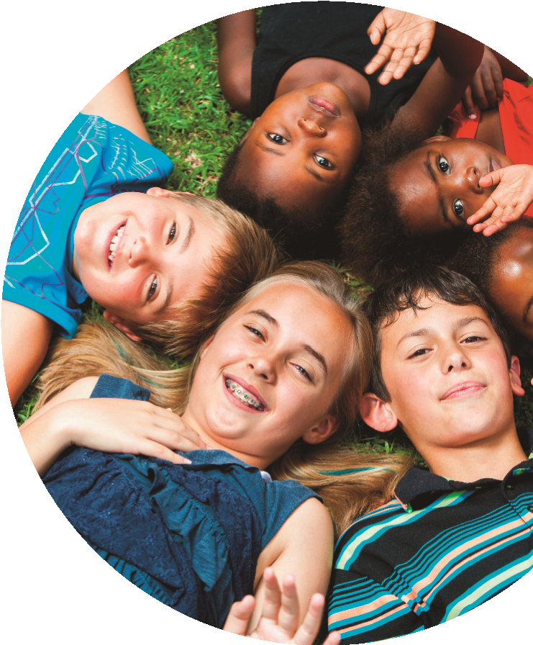
If you have questions about your child’s education and would like to talk to someone confidentially, please contact the Virtual School Team.
Has your child been
adopted from Care?
Is your child currently living with you
under a Special Guardianship Order
or Child Arrangement Order, but has
been looked after in the past under
the Care of a Local Authority?
Does your child attend a
School in Halton?
Support for
Previously
Looked After
Children
The Virtual School Team can offer advice and guidance, and support you in meetings with your child’s school.
You can learn about funding your child’s school could be entitled to as well as other local services that may be able to help you and your child.
The Virtual School Team can only discuss a previously looked after child with the consent of the person with parental responsibility. They will not discuss any child with other professionals without this permission.
Telephone number: 0151 511 7391 alternatively, you can email us on:
virtual.school@halton.gov.uk

