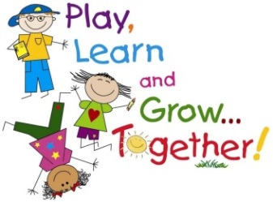

Early Years Personal Education Plan
Name:

EARLY YEARS PEP
My name is:
My date of birth is:
My current age in months is:
My early years setting/school is:
The name of my Key Person/Designated Teacher is:
The name of my social worker is:
The name of my parent/carer is:
My attendance this term was:
The date of my EYPEP meeting:
Is this my first PEP or a review PEP?
The date of my next 2 EYPEP meetings are:

SEN/Additional Needs | (Please attach any additional documents)
No SEN | Y/N
Causing concern | Y/N
Support Plan | Y/N
Enhanced Provision | Y/N
EHCP | Y/N Review date:
Primary need:
Secondary need:

School | Yes/No
Carers | Yes/No
Details/Actions taken:

The Early Years Setting or School will provide the following assessment information for each PEP and forward the completed document following the meeting (or within 5 working days) to joanne.lloyd@halton.gov.uk (EYFS & Primary PEP Coordinator) to be reviewed. If PP+ requests need clarification, the PEP coordinator will contact schools for further information.

Review of Previous Steps and Progress Made:
Targets from last PEP | Achieved  Yes/No | Previous Attainment | Current Attainment | Progress and impact of PP+
1.

2.

3.

4.

How am I doing now?
Please provide a summary of strengths and any areas requiring support – including comments from all relevant parties. Include termly Boxall Profiles.

Setting

Carers

Social worker

What I want you to know.
(To be completed by the child or with the support of the designated teacher)
My Friends are:
I Like:

If I have a problem in school I can talk to:

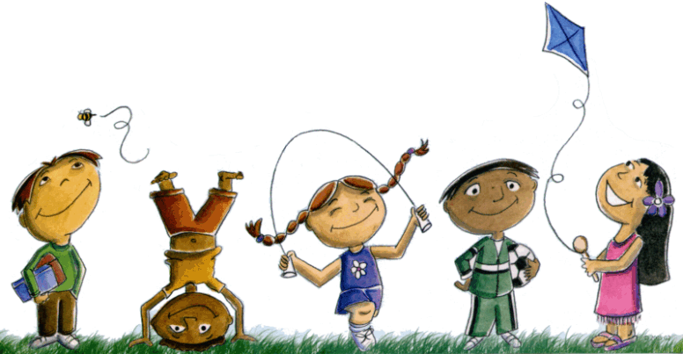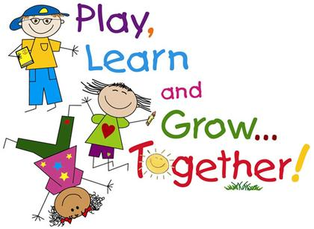
I’m good at:

I’m trying to get better at:

When I’m older, I would like to be:
People I like to spend time with:

Would I like to attend my PEP meeting? Yes / No
Summative Assessments
Key for Summative Assessments
E = entering
D = developing
S = secure
Please insert Autumn assessment in brown ink, spring assessment in green ink and summer assessment in blue ink.
Prime Areas
Date current assessments were made: _______________
Personal, Social and Emotional Development
Making Relationships | 0-11 months | 8 – 20  Months | 16 – 26 months | 22 – 36 months | 30 – 50 months | 40 – 60 months
Self-Confidence and Self-Awareness | 0-11 months | 8 – 20  months | 16 – 26 months | 22 – 36 months | 30 – 50 months | 40 – 60 months
Managing Feelings and Behaviour | 0-11 months | 8 – 20  months | 16 – 26 months | 22 – 36 months | 30 – 50 months | 40 – 60 months

Communication and Language
Listening and Attention | 0-11 months | 8 – 20  months | 16 – 26 months | 22 – 36 months | 30 – 50 months | 40 – 60 months
Understanding | 0-11 months | 8 – 20  months | 16 – 26 months | 22 – 36 months | 30 – 50 months | 40 – 60 months
Speaking | 0-11 months | 8 – 20  months | 16 – 26 months | 22 – 36 months | 30 – 50 months | 40 – 60 months

Physical Development
Moving and Handling | 0-11 months | 8 – 20  months | 16 – 26 months | 22 – 36 months | 30 – 50 months | 40 – 60 months
Health and Self-Care | 0-11 months | 8 – 20  months | 16 – 26 months | 22 – 36 months | 30 – 50 months | 40 – 60 months

Specific Areas
Literacy
Reading | 0-11 months | 8 – 20  months | 16 – 26 months | 22 – 36 months | 30 – 50 months | 40 – 60 months
Writing | 0-11 months | 8 – 20  months | 16 – 26 months | 22 – 36 months | 30 – 50 months | 40 – 60 months

Mathematics
Numbers | 0-11 months | 8 – 20  months | 16 – 26 months | 22 – 36 months | 30 – 50 months | 40 – 60 months
Shape, Space and Measures | 0-11 months | 8 – 20  months | 16 – 26 months | 22 – 36 months | 30 – 50 months | 40 – 60 months

Understanding the World
People and Communities | 0-11 months | 8 – 20  months | 16 – 26 months | 22 – 36 months | 30 – 50 months | 40 – 60 months
The World | 0-11 months | 8 – 20  months | 16 – 26 months | 22 – 36 months | 30 – 50 months | 40 – 60 months
Technology | 0-11 months | 8 – 20  months | 16 – 26 months | 22 – 36 months | 30 – 50 months | 40 – 60 months
Expressive Arts and Design
Exploring and Using Media and Materials | 0-11 months | 8 – 20  months | 16 – 26 months | 22 – 36 months | 30 – 50 months | 40 – 60 months
Being Imaginative | 0-11 months | 8 – 20  months | 16 – 26 months | 22 – 36 months | 30 – 50 months | 40 – 60 months

Early Learning Goal Predictions
Key for Early Learning Goals:
- Emerging – If a child is described as emerging, please describe the age band in ‘development matters’ which best describes the child’s development.
- Expected – the development expected by the end of the Early Years Foundation Stage
- Exceeding – describes attainment beyond that which is expected by the end of the Early Years Foundation Stage

If the child is described as EMERGING at the end of EYFS then consideration should be given to continuing within the EYFS on transition to Y1 and continue to use the EYFS PEP.
Prime Areas  Stages of Development |  | Personal, Social and Emotional Development |  |  | Communication and Language |  |  | Physical Development
 |  | Making relationships | Self-confidence and self-awareness | Managing feelings and behaviour | Listening and attention | Understanding | Speaking | Moving and handling | Health and self-care
Early Learning Goals | Emerging
 | Expected
 | Exceeding

Specific Areas  Stages of Development |  | Literacy |  | Mathematics |  | Understanding the world |  |  | Expressive arts and design
 |  | Reading | Writing | Numbers | Shape, space and measure | People and communities | The world | Technology | Exploring and using media and materials | Being imaginative
Early Learning Goals | Emerging
 | Expected
 | Exceeding

Good Level of Development – am I | Emerging
 | Achieving
 | Exceeding

My next steps are:
 | What is my target? | Why do I need this target? | What do I need to do to achieve it? | Who will help me achieve it and what will they do? | When do I need to achieve it by? | How will I know I am on track?
1
2
3

Do you wish to apply for Early Years Pupil Premium? Yes / No
Which target(s) will my Pupil Premium be used for? | What will the Pupil Premium be used for? | How much will each intervention cost for the term? (Please provide hourly rate is possible) | How will the impact of the Pupil Premium be measured?

