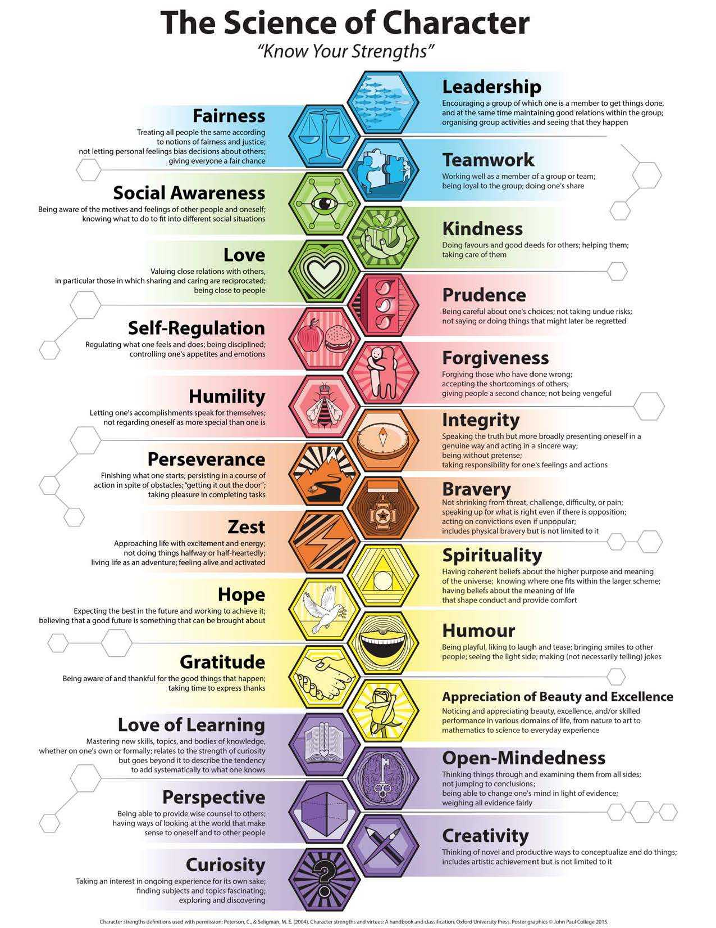engths

*Strengths of Self*

*Community Strengths*

*Strengths of Others*

*Head Strengths*

**Wisdom**

*Spiritual Strengths*

**Transcendence**

**Courage**

**Humanity**

**Temperance**

**Justice**

*Heart Strengths*